Use Case Name: Database

# Description:

### This use case begin when user click on register button.to use the website user need to create a account.the register page will ask for the information like name address,username and pasword.If there is another user with same username it will ask them enter new username..

# Actors:

* User.

# trigger:

### When the user click on Sig in button..

# preconditions:

### The user must be greater than 18 years old. .

# basic FLOW :

### The user click on the Sig in button.

### He will be taken to the register page .

### User need to provide the required information.

### It will check in the database if the username is unique .

# Alternates:

NO

# Exceptions:

### When there is a buffer time error or the server connection might get lost or the input is other than the required.

# postconditions:

### After registering he will redirected to the login page .

# Stakeholders:

NIL.

# Noun-Phrases Identified:

### User,sigin,name,age,address,username,password,phno,database,dbusrename

# conceptual class:

### User,register,database.

# Object diagram:

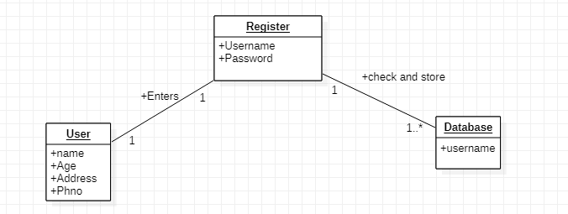

# Sequence diagram: